F009 - RISK ASSESSMENT
Activity / Task / Location:  Work Experience – Green Connect Farm |  | Reviewed / Approved By:  Signature:
Developed by:  Callum Champagne | Date:  10/03/2020 |  | Review Date:

 | Risk Matrix | LIKELIHOOD
 |  | Highly unlikely, but it may occur in exceptional circumstances. It could happen, but probably never will. | The event might occur at some time as there is a history of casual occurrence | There is a strong possibility the event will occur as there is a history of frequent occurrence | Very likely. The event is expected to occur in most circumstances as there is a history of regular occurrence
 |  | Unlikely / Rare (U) | Possible (P) | Likely (L) | Almost Certain (C)
CONSEQUENCE | 1. Severe or Catastrophic Eg. Kill or Permanently Maim | MEDIUM | HIGH | EXTREME | EXTREME
 | 2. Major Eg. Long term Injury or Illness | MEDIUM | MEDIUM | HIGH | EXTREME
 | 3. Moderate Eg. Medical Attention with several days off work | LOW | MEDIUM | MEDIUM | HIGH
 | 4. Minor Eg. First Aid Needed | LOW | LOW | MEDIUM | MEDIUM

Summary of Requirements
Personal Protective Equipment | Non-slip enclosed shoes, sun hat and sunscreen, rain coat.
Training/Equipment | Farm induction
Refer to Page 3 for some possible hazards
Hazard Identification |  |  | Control | Risk Assessment
Task | What are the potential hazards | What methods/controls will be used to reduce the hazards  What hazard remains Additional Controls |  | What is the level of risk remaining based on the Risk Assessment matrix
Walking around the Green Connect farm | Slip, trip and falls due to uneven ground | - Workers advised of slip and trip hazards and to take care when walking as part of the farm induction when they arrive on site  - Running on site to be actively discouraged |  | Medium
 | Snake bite | - All workers to wear sturdy, enclosed shoes.  - At induction, visitors advised of the presence of snakes on site and to immediately tell a staff member if they see one  - When a snake is sighted, all persons present to be notified that one (or more) has been seen and its location.  - Snake bite kit available within the farm hub and trained first aiders available on site |  | Medium
 | Bee or other insect stings | - Visitors advised of the presence of bees on site as part of the farm induction, and asked to declare if they are allergic. Those who are allergic are asked to present their Epipen, as well as keep clear of the beehives  - No visitors to handle bees, beehives or other insects. They will remain 10m or more from the beehives to best avoid being stung  - First aid kit and Epipen available within the farm hub and trained first aiders available on site  - Visitors are advised to bring personal supply of insect repellent and know how to apply it, if they are concerned about insects |  | Medium
 | Asbestos exposure | - Visitors advised that bonded asbestos has previously been found on site and to alert a staff member if building materials are spotted anywhere on sit |  | Low
 | Injury from tools or machinery | - Visitors advised that there are tools and machinery on site and they are not to touch them without express permission from a staff member  - No one to go within one metre of anyone using tools or machinery  - First aid kit available within the farm hub and trained first aiders available on site |  | Medium
Visiting the animals | Electric shock from fencing | - Visitors advised that there is white electrical tape around some animal enclosures and not to touch it to avoid getting a shock  - Groups to stay one metre or further from electrical tape always |  | Low
 | Animal bites | - Visitors advised to touch any animals at their own risk  - Visitors must not attempt to pick up chickens, pigs, sheep or goats at any time without permission  - When feeding the animals (e.g. pigs), visitors to throw food to them rather than hand-feeding them |  | Low
Harvesting or planting produce | Allergic reaction to soil, compost etc | - Wearing of gloves is advised but optional, visitors need to bring their own.  - Planting will take place in well ventilated, outdoor area.  - Suitable planting materials are selected and will be kept damp to reduce particle exposure. Hands will be washed after planting takes place.  - First aid kit available within the farm hub and trained first aiders available on site |  | Low
 | Cut or sting from a plant e.g. stinging nettle | - At induction, visitors are briefed on the risks of touching and handling plants with prickles, spikes, thorns or other sharp protrusions.  - First aid kit available within the farm hub and trained first aiders available on site  - Stinging nettles are found on site and areas of concern will be identified by the supervisor.  - Visitors advised not to pick or tear any plant unless otherwise asked to  - Low-hanging branches pose a risk to scratching faces and eyes so visitors are asked to avoid those areas. |  | Low
 | Nut allergies  Asthma | - Tree and other nuts are present on the farm e.g. peanuts. Supervisors to know where these are and to discourage visitors from touching them. Nuts found on the ground are not to be picked up. |  | Low
 | Poor student behaviour that compromises safety | - Students and participants to be briefed on expected quality of behaviour  - Measures in place for dangerously disruptive students and participants to be picked up by other staff from visiting school/group  - Dangerous behaviour to be reported to farm manager and visitor banned from re-entering the site. |  | Low
 | Heat exhaustion, dehydration, sunburn | - All visitors, students and participants are required to bring at least one 600ml bottle of water.  - Sunscreen is available onsite.  - All students, participants and staff are required to wear hats, protective clothing and closed footwear when participating in lessons and activities. |  | Low

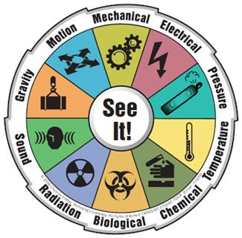  A Possible Hazards:  - Noise  - Light  - Radiation  - Toxicity  - Infection  - High or low temperatures  - Electricity  - Flammable or explosive materials  - Things under tension or pressure (compressed gas or liquid; springs)  - Any other energy sources or stresses  - Biohazardous material  - Physical – lifting, pulling, pushing  - Gravitational – Slips, trips and falls, ladders, steps, falling objects  - Mechanical - hazards caused by equipment and vehicles and include: electricity associated with plant, machinery, equipment, pressure vessels, dangerous goods, forklifts, hoists and vibration  - Psychosocial – working remotely or alone; repetitive tasks | 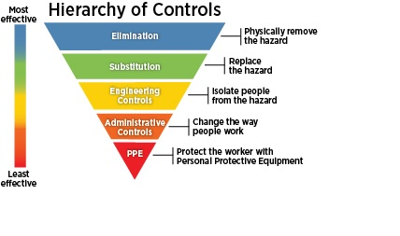  B Controlling the Risk
Assessing the Risk
Step 1 – Consider the Consequences  What are the consequences of this incident occurring?  Consider what could reasonably have happened as well as what actually happened. | Step 2 – Consider the Likelihood  What is the likelihood of the consequence identified in step 1 happening? Consider this with the current controls in place. | Step 3 – Calculate the Risk  A. Take Step 1 rating and select the correct column.  B. Take Step 2 Rating and select the correct line.  C. The calculated risk score is where the two ratings cross  on the matrix below.

